1. Executive Summary
The Sunrise Dental Management System was developed to replace the manual paper-based appointment and patient management process used by Sunrise Dental Clinic in Colombo. The existing manual approach creates several operational problems, including double bookings, difficulty locating patient information, lengthy administrative procedures and billing inaccuracies.
The proposed system is a web-based dental management application developed using Java 23, Jakarta Servlets, JSP, JDBC, MySQL and Apache Tomcat 11. The application follows a multi-tier layered architecture consisting of the presentation layer, Servlet/controller layer, service layer, DAO layer, model layer and relational database.
The system provides secure staff authentication, role-based access control, patient registration, dentist management, treatment management, appointment scheduling, appointment searching, billing, printable receipts, operational reports and an integrated help section.
A major design objective was to maintain a clear separation of responsibilities. HTTP requests are received by Jakarta Servlets, business rules are processed by service classes, database operations are isolated within Data Access Objects, and persistent information is stored in MySQL. This approach improves maintainability, testability and scalability.
The system also implements validation at multiple levels. Client-side validation provides immediate feedback to users, while server-side validation prevents invalid or malicious input from reaching the business and database layers. Prepared statements are used for database operations to reduce the risk of SQL injection.
Automated testing was implemented using JUnit and Mockito. The implemented test suite contains 87 automated tests covering important authentication, validation, appointment, billing, user-management and DAO functionality. The reported execution result was 87 passed tests with zero failures and zero errors.
Git and GitHub are used for version control and development tracking. The project can be packaged as a WAR file using Maven and deployed to Apache Tomcat 11.

2. Introduction
2.1 Background
Dental clinics handle a significant amount of information on a daily basis. This includes patient information, dentist schedules, treatment information, appointments and financial transactions. When such information is maintained using paper files and notebooks, administrative activities become time-consuming and vulnerable to human error.
Sunrise Dental Clinic is a private dental center in Colombo that previously relied on manual methods for managing patient appointments and treatment-related information. As the number of patients increases, the limitations of the existing process become more significant.
The proposed Sunrise Dental Management System provides a centralized computerized solution that enables authorized clinic staff to manage important operational activities through a web-based interface.
2.2 Problem Statement
The manual system creates several problems:
- Appointment information can be recorded incorrectly.
- Dentists may be accidentally double-booked.
- Paper patient records can be misplaced.
- Searching for previous appointment information is time-consuming.
- Billing calculations can contain human errors.
- There is limited control over who can access confidential information.
- Generating operational and financial reports manually requires considerable effort.
- Historical information is difficult to analyze efficiently.
Therefore, a computerized system is required to improve accuracy, security, accessibility and operational efficiency.
2.3 Aim
The main aim of the project is to develop a secure and user-friendly computerized dental management system that centralizes patient, appointment, treatment and billing information while reducing the problems associated with manual record management.
2.4 Objectives
The main objectives are:
- Develop a secure staff authentication mechanism.
- Provide role-based access to system functionality.
- Register and maintain patient information electronically.
- Maintain dentist information.
- Maintain available dental treatments and associated fees.
- Register and search appointments using unique appointment numbers.
- Prevent conflicting dentist appointments.
- Automatically calculate treatment bills.
- Generate printable patient receipts.
- Produce useful operational and financial reports.
- Provide validation and meaningful error messages.
- Maintain persistent information using a relational database.
- Apply suitable software design patterns.
- Develop automated tests for important business functions.
- Use Git and GitHub for version control and project development.
2.5 Scope of the System
The system focuses on the internal management activities of a single dental clinic.
The main modules are:
- Authentication
- Dashboard
- User Management
- Patient Management
- Dentist Management
- Treatment Management
- Appointment Management
- Billing
- Reports
- Help
The system does not currently include online payment processing, SMS notifications, email notifications or multi-branch management.
2.6 Intended Users
Three primary roles were defined.
Administrator
Administrators are responsible for managing system users and accessing administrative functionality.
Receptionist
Receptionists primarily manage patients, appointments and billing.
Dentist
Dentists can access clinical information and appointment-related information relevant to their work.
Role separation was introduced because different employees require different levels of access. This reduces unnecessary access to administrative functionality.
2.7 Assumptions
The following assumptions were made:
- Sunrise Dental operates as a single clinic.
- Each patient has a unique patient number.
- Each appointment has a unique appointment number.
- Each dentist has a unique dentist number.
- Each treatment has a unique treatment code.
- An appointment is associated with one patient, one dentist and one treatment.
- An appointment can have a maximum of one bill.
- Appointment times are represented by a date and starting time.
- Clinic staff have valid system accounts before accessing protected functionality.
- Billing is performed internally by clinic staff.
- The system operates using Sri Lankan Rupees.
These assumptions simplify the system while remaining consistent with the scenario provided.
3. Requirements Analysis
3.1 Functional Requirements
The system must provide the following functionality.
Requirement | Description
Authentication | Staff must log in using a username and password
User Management | Administrators can manage system accounts
Patient Registration | Staff can register new patients
Patient Search | Staff can find patients using their patient number
Dentist Management | Dentist information can be registered and maintained
Treatment Management | Treatment information and fees can be maintained
Appointment Registration | Staff can create appointments
Appointment Search | Appointments can be searched using appointment numbers
Conflict Prevention | Dentist double bookings must be prevented
Appointment Status | Appointments can be scheduled, completed, cancelled or marked as no-show
Billing | Bills can be generated from appointment information
Receipt Printing | Bills can be printed
Reporting | Operational and financial information can be summarized
Help | New staff can access system instructions
Logout | Users can safely terminate their sessions

3.2 Non-Functional Requirements
Usability
The system should provide simple navigation, clear forms and understandable feedback messages.
Security
Only authenticated users should access protected functionality. Passwords should not be stored in plaintext.
Reliability
Database constraints and application-level validation should prevent inconsistent information.
Maintainability
The application should separate presentation, business logic and database operations.
Performance
Database operations should use indexed fields and parameterized SQL queries.
Scalability
The layered architecture allows additional modules to be introduced without significantly modifying existing layers.
Portability
The application is packaged as a WAR file and can be deployed to an Apache Tomcat environment.

3.3 Business Rules
Business rules define the policies and constraints that control how the Sunrise Dental Management System operates. These rules ensure that the system processes information consistently, protects data integrity and prevents invalid business operations.
The following business rules were identified based on the requirements of the dental clinic and the functionality implemented in the system.
Business Rule ID | Business Rule
BR-01 | Each system user must have a unique username.
BR-02 | Only users with an active account are permitted to log into the system.
BR-03 | Users must be authenticated before accessing protected system functionality.
BR-04 | Access to system functionality must be controlled according to the user's assigned role.
BR-05 | Only administrators are permitted to manage system user accounts.
BR-06 | An administrator cannot deactivate their own account while logged into the system.
BR-07 | The last active administrator account cannot be deactivated, preventing the system from being left without an administrator.
BR-08 | Each patient must have a unique patient number.
BR-09 | Each dentist must have a unique dentist number.
BR-10 | Each treatment must have a unique treatment code.
BR-11 | Each appointment must have a unique appointment number.
BR-12 | An appointment must be associated with one valid patient, one valid dentist and one valid treatment.
BR-13 | A dentist cannot have more than one active appointment at the same date and time.
BR-14 | A cancelled appointment does not prevent another appointment from being scheduled for the same dentist, date and time.
BR-15 | An appointment status must be one of the supported values: SCHEDULED, COMPLETED, CANCELLED or NO_SHOW.
BR-16 | Treatment fees and consultation fees must not contain negative values.
BR-17 | A bill can only be generated for a valid appointment.
BR-18 | Each appointment can have a maximum of one bill.
BR-19 | The bill total must be calculated as the consultation fee plus the treatment cost.
BR-20 | Historical appointment information must be preserved when dentists or treatments are no longer active. Therefore, dentists and treatments are deactivated rather than permanently deleted.
BR-21 | Database records that are required by dependent historical records must not be removed in a way that violates foreign key relationships.
BR-22 | Sensitive passwords must not be stored in plaintext and must be stored using secure password hashing.
BR-23 | All database operations involving user input must use parameterized queries to reduce the risk of SQL injection.
BR-24 | Required information must be validated before a record is stored or updated.
BR-25 | Invalid or incomplete data must be rejected with meaningful feedback to the user.

These business rules are enforced across multiple layers of the application. User interface validation provides immediate feedback for simple input errors, while the service layer applies important business rules before database operations are performed. The database provides an additional level of protection through primary keys, unique constraints, foreign keys, NOT NULL constraints and appropriate data types.
For example, the appointment conflict rule is enforced before an appointment is saved, while the unique constraint on the bill's appointment reference prevents the creation of multiple bills for the same appointment. Similarly, authentication and role-based authorization ensure that users can only access functionality appropriate to their responsibilities.
The identified business rules provide a clear set of constraints for the design, implementation and testing of the Sunrise Dental Management System. They also support the Requirements Traceability Matrix in Section 3.4 by allowing important requirements and business constraints to be traced through implementation and verification activities.

3.4 Requirements Traceability Matrix (RTM)
A Requirements Traceability Matrix (RTM) was used to establish a clear relationship between the system requirements, the corresponding design and implementation components, and the testing activities used to verify them.
The RTM helps ensure that important requirements identified during the analysis stage are not omitted during system development. Each functional requirement is assigned a unique requirement identifier and traced to the relevant system module and verification activity.
Requirement ID | Functional Requirement | Related Module / Implementation | Verification
FR-01 | The system shall allow authorized staff to log in using a username and password. | LoginServlet, AuthService, UserDAO, Login JSP | Valid login and invalid login tests
FR-02 | The system shall provide role-based access to protected functionality. | AuthenticationFilter, session handling and role validation | Authorization and role access tests
FR-03 | The system shall allow administrators to manage system user accounts. | UserServlet, UserService, UserDAO | User management tests
FR-04 | The system shall allow staff to register and maintain patient information. | PatientServlet, PatientService, PatientDAO | Patient registration and validation tests
FR-05 | The system shall allow staff to search for patient information. | PatientServlet, PatientService, PatientDAO | Patient search tests
FR-06 | The system shall allow authorized users to register and maintain dentist information. | DentistServlet, DentistService, DentistDAO | Dentist management tests
FR-07 | The system shall allow authorized users to register and maintain treatment information and fees. | TreatmentServlet, TreatmentService, TreatmentDAO | Treatment validation and fee tests
FR-08 | The system shall allow staff to create appointments using patient, dentist, treatment, date and time information. | AppointmentServlet, AppointmentService, AppointmentDAO | Appointment registration tests
FR-09 | The system shall allow appointments to be searched using an appointment number. | AppointmentServlet, AppointmentService, AppointmentDAO | Appointment search tests
FR-10 | The system shall prevent a dentist from being double-booked for the same date and time. | AppointmentService, AppointmentDAO conflict checking | Dentist schedule conflict tests
FR-11 | The system shall support appointment statuses including Scheduled, Completed, Cancelled and No-Show. | Appointment model, AppointmentService and database status field | Appointment status validation tests
FR-12 | The system shall generate a bill using the selected appointment and treatment information. | BillServlet, BillService, BillDAO | Bill generation tests
FR-13 | The system shall calculate the total bill correctly. | BillService calculation logic | Bill total calculation tests
FR-14 | The system shall prevent multiple bills from being created for the same appointment. | BillService, BillDAO and unique appointment_id constraint | Duplicate bill tests
FR-15 | The system shall provide a printable receipt containing appointment and billing information. | Billing JSP and browser print functionality | Manual receipt printing verification
FR-16 | The system shall provide operational and financial reports. | ReportServlet, ReportDAO and reporting views | Report output verification
FR-17 | The system shall provide help and guidance for system users. | HelpServlet and Help JSP | Manual interface verification
FR-18 | The system shall allow authenticated users to safely log out. | LogoutServlet and HTTP session invalidation | Logout tests
NFR-01 | The system shall protect passwords from plaintext storage. | BCrypt password hashing in authentication functionality | Authentication and password security verification
NFR-02 | The system shall protect database operations from SQL injection. | JDBC PreparedStatement usage in DAO classes | DAO and security-related verification
NFR-03 | The system shall validate important input before data is stored. | Client-side validation and Service Layer validation | Validation test cases
NFR-04 | The system shall maintain data integrity using database constraints. | Primary keys, foreign keys, unique constraints and NOT NULL constraints | Database and integration-oriented tests
NFR-05 | The system shall maintain separation between presentation, business and database logic. | JSP/Servlet → Service → DAO → Model architecture | Code structure and design review
NFR-06 | The system shall provide understandable feedback and error messages. | Validation messages, JSP feedback and exception handling | Manual user interface testing
NFR-07 | The system shall support maintainable and testable software development. | Layered architecture, DAO pattern, Service Layer pattern, JUnit and Mockito tests | Code review and automated testing

The Requirements Traceability Matrix demonstrates that the identified requirements were considered throughout the software development lifecycle. Functional requirements were mapped to the relevant application components, while important business and quality requirements were linked to validation, database constraints, security mechanisms and testing activities.
This traceability improves confidence that the implemented Sunrise Dental Management System addresses the requirements identified during the requirements analysis stage. It also provides evidence that the system requirements can be traced forward into design, implementation and testing.
4. System Analysis and UML Design
4.1 Use Case Diagram
The Use Case Diagram represents the functional interactions between users and the system.
The main actors are:
- Administrator
- Receptionist
- Dentist
The main use cases are:
- Login
- Logout
- Manage Users
- Manage Patients
- Manage Dentists
- Manage Treatments
- Manage Appointments
- Search Appointment
- Generate Bill
- Print Bill
- View Reports
- View Help

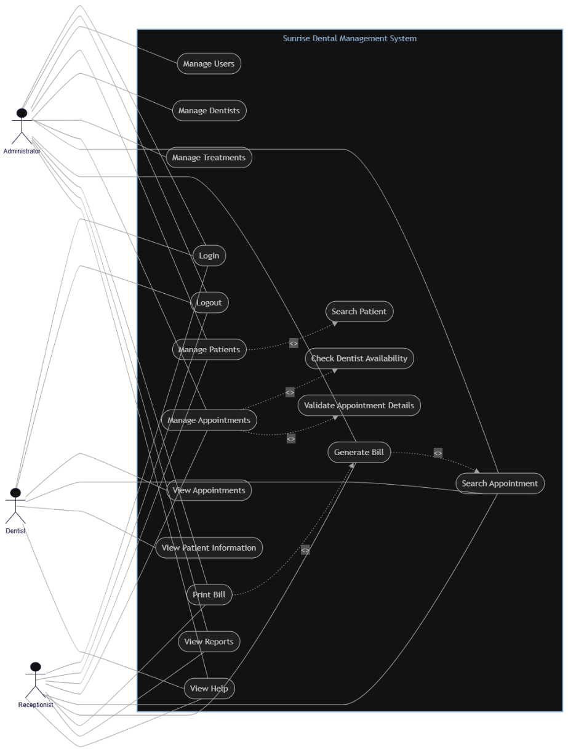
Figure 1: Sunrise Dental Management System Use Case Diagram
The Administrator has the highest access level because administrative account management should not be available to ordinary staff.
The Receptionist has access to patient registration, appointments and billing because these activities are central to reception operations.
The Dentist requires access to appointments and patient information relevant to clinical work.

4.2 Detailed Use Case – Register Appointment
Use Case: Register New Appointment
Primary Actor: Receptionist
Precondition: User is authenticated.
Postcondition: Appointment is stored successfully.
Main Flow
- Receptionist opens the appointment module.
- The system displays available patients.
- The receptionist selects a patient.
- The receptionist selects a dentist.
- The receptionist selects a treatment.
- The receptionist enters appointment date and time.
- The system validates the input.
- The system checks whether the appointment number already exists.
- The system checks whether the dentist is already booked.
- If no conflict exists, the appointment is stored.
- The system displays a success message.
Alternative Flow
If the dentist is already booked at the selected time, the system rejects the appointment and displays a meaningful error message.
This prevents one of the primary problems identified in the scenario: double booking.

4.3 Class Diagram
The Class Diagram represents the structural organization of the application.
The major domain classes are:
- User
- Patient
- Dentist
- Treatment
- Appointment
- Bill
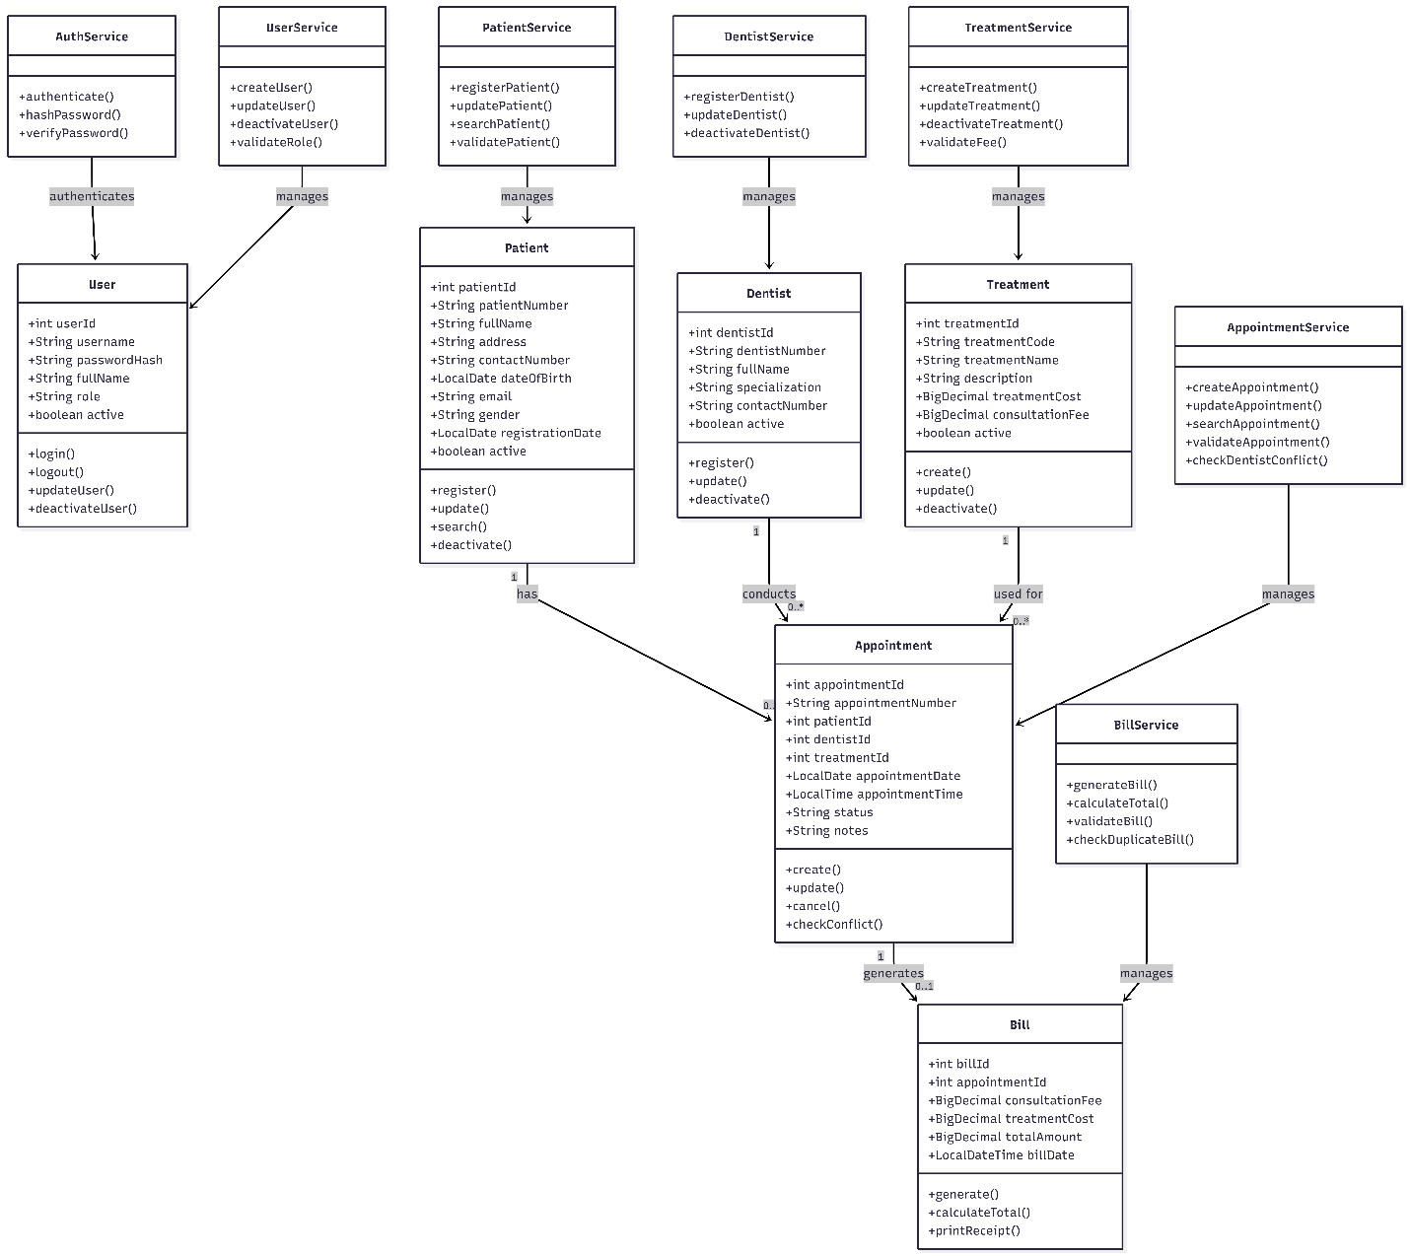
Reporting DTOs are also used for specialized reporting operations.
Figure 2: Sunrise Dental Management System Class Diagram
The Appointment class acts as an important relationship between the Patient, Dentist and Treatment entities.
A patient can have multiple appointments, while each appointment belongs to one patient.
Similarly, a dentist can have multiple appointments, while each appointment belongs to one dentist.
An appointment can have zero or one associated bill.

4.4 Sequence Diagram – Login
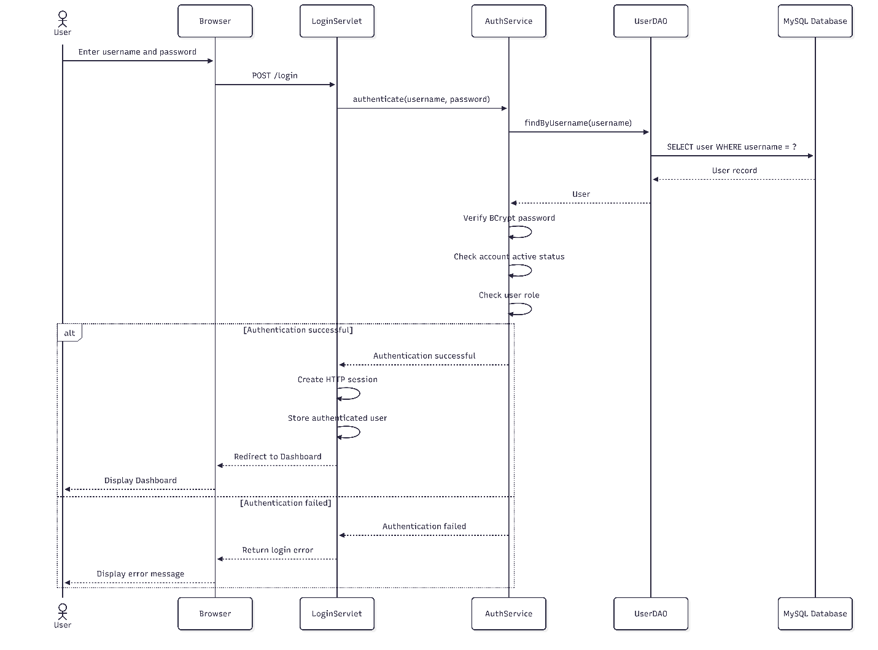
Figure 3: Login Sequence Diagram
The login sequence begins when the user submits credentials.
The request is received by LoginServlet, which delegates authentication to AuthService. The service retrieves the user through UserDAO, and the stored BCrypt password hash is compared with the supplied password.
If authentication succeeds, a session is created and the authenticated user is stored in the session.
This approach prevents the Servlet from directly handling database operations and therefore maintains separation of concerns.

4.5 Sequence Diagram – Appointment Registration
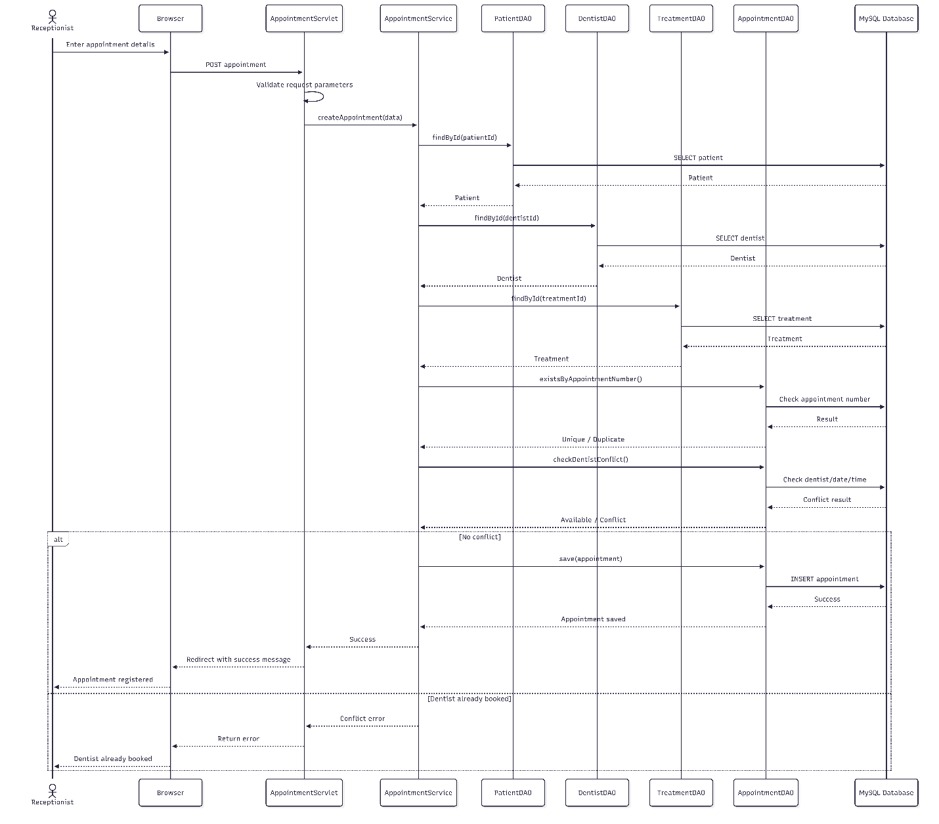
Figure 4: Appointment Registration Sequence Diagram
The appointment registration process demonstrates the layered architecture.
The browser sends an HTTP POST request to AppointmentServlet.
The Servlet extracts the request parameters and converts values such as IDs, dates and times into suitable Java types.
The request is then passed to AppointmentService.
The service performs business validation and calls AppointmentDAO.
The DAO executes parameterized SQL using JDBC.
After successful insertion, the Servlet redirects the user back to the appointment page with a success message.

4.6 Sequence Diagram – Billing
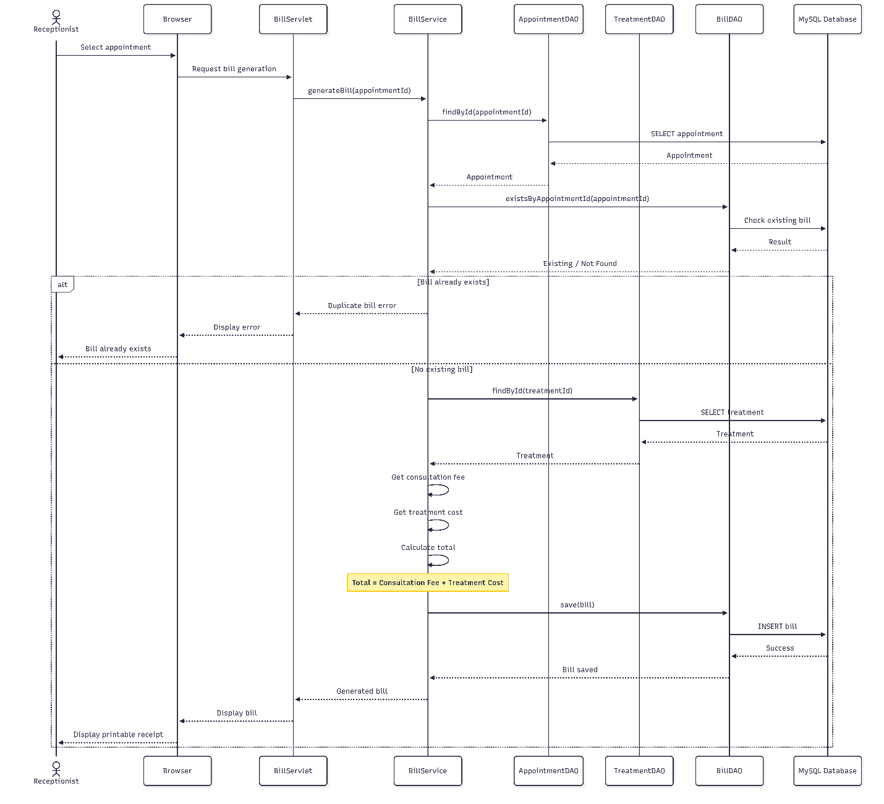
Figure 5: Billing Sequence Diagram
The billing process retrieves the appointment and its associated treatment information.
The treatment contains:
- Consultation fee
- Treatment cost
The system calculates:
Total Amount = Consultation Fee + Treatment Cost
The resulting bill is stored in the database and displayed using the billing interface.
A unique constraint on appointment_id ensures that the same appointment cannot receive multiple bills.

4.7 Design Decisions
Several design decisions were made during development.
Layered Architecture
Layered architecture was selected because it separates responsibilities and improves maintainability.
DAO Pattern
Database operations are isolated inside DAO classes. This prevents SQL code from being distributed across Servlets and JSP files.
Service Layer
Business rules such as appointment conflict detection and bill calculation are implemented in service classes.
Prepared Statements
Prepared statements were selected to parameterize database input and reduce SQL injection risks.
Soft Deactivation
Dentists and treatments use an active field instead of being permanently deleted. This preserves historical information referenced by appointments.

5. System Development
5.1 Technology Selection
The application was developed using technologies appropriate for the assignment requirements.
Technology | Purpose
Java 23 | Main programming language
Jakarta Servlet API | HTTP request handling
JSP | Dynamic server-side presentation
HTML5 | Interface structure
CSS | User interface styling
JavaScript | Client-side interaction and validation
JDBC | Database communication
MySQL | Persistent relational storage
Maven | Dependency and build management
Apache Tomcat 11 | Application server
JUnit | Automated testing
Mockito | Test isolation
BCrypt | Password hashing
Git/GitHub | Version control

The system deliberately does not use Spring Boot, Spring MVC, Hibernate or JPA because the project requirements require a standard Java web application approach.

5.2 System Architecture
The system uses the following architecture:
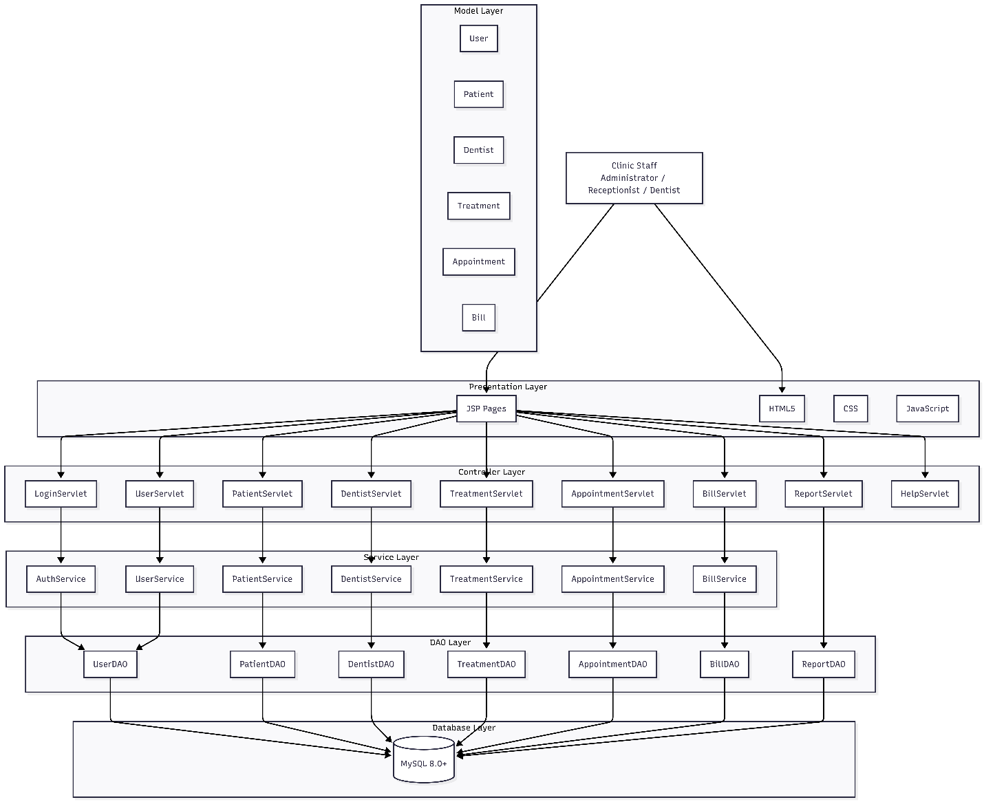
Figure 6: System Architecture Diagram
The architecture provides clear separation of concerns.
Presentation Layer
Responsible for displaying forms, tables, dashboards and reports.
Controller Layer
Responsible for HTTP request processing and navigation.
Service Layer
Responsible for business rules and validation.
DAO Layer
Responsible for database operations.
Model Layer
Represents application data.
Database Layer
Provides persistent storage.

5.3 Presentation Layer
The presentation layer uses HTML, JSP, CSS and JavaScript.
Major interfaces include:
- Login
- Dashboard
- Patients
- Dentists
- Treatments
- Appointments
- Billing
- Reports
- User Management
- Help
JSP pages are used when server-generated data needs to be displayed.
For example, the dashboard receives KPI values from the backend and dynamically displays them.

5.4 Controller Layer
Jakarta Servlets act as controllers.
Important Servlet classes include:
- LoginServlet
- LogoutServlet
- DashboardServlet
- UserServlet
- PatientServlet
- DentistServlet
- TreatmentServlet
- AppointmentServlet
- BillServlet
- ReportServlet
- AppointmentReportServlet
- HelpServlet
The controllers do not directly contain SQL operations.
Instead, they delegate business operations to service classes.
This makes the controllers easier to understand and test.

5.5 Service Layer
The service layer contains business rules.
For example, AppointmentService performs:
- Required-field validation
- Appointment number uniqueness checks
- ID validation
- Date and time validation
- Appointment status validation
- Dentist conflict detection
BillService performs:
- Bill validation
- Duplicate bill prevention
- Fee calculation
- Total calculation
This ensures that business rules are not dependent on the user interface.

5.6 DAO Layer
The DAO layer uses JDBC to communicate with MySQL.
Examples include:
- UserDAO
- PatientDAO
- DentistDAO
- TreatmentDAO
- AppointmentDAO
- BillDAO
- DashboardDAO
- ReportDAO
All SQL statements use PreparedStatement.
For example, user searches are parameterized rather than constructing SQL statements by concatenating user input.
This improves security and database reliability.

5.7 Model Layer
The model classes represent domain entities.
The major classes are:
User, Patient, Dentist, Treatment, Appointment and Bill.
Additional DTO-style classes are used for reporting information.
This separation prevents database-specific structures from being directly coupled to presentation components.

5.8 Database Layer
The database contains six primary tables:
- users
- patients
- dentists
- treatments
- appointments
- bills
The database uses InnoDB and foreign keys to maintain relationships between records.

5.9 Design Patterns
Several established design approaches are used.
Model-View-Controller
The system separates:
- Model – application data
- View – JSP/HTML interfaces
- Controller – Servlets
This prevents presentation code from becoming responsible for business operations.
Data Access Object
The DAO pattern isolates database operations.
For example, PatientDAO handles SQL operations associated with patients.
Service Layer Pattern
Service classes encapsulate business logic between the controller and DAO layers.
Front Controller-like Request Handling
Servlets provide centralized request handling for individual application modules while the authentication filter provides cross-cutting request protection.
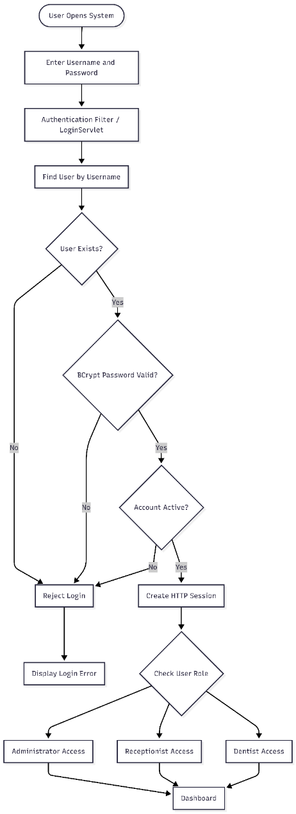
5.10 Authentication and Authorization
The login mechanism requires:
- Username
- Password
Passwords are stored as BCrypt hashes rather than plaintext.
After successful authentication, the user is stored in an HTTP session.
The AuthenticationFilter protects secure application routes.
Role-based access control is also implemented.
For example, User Management is restricted to administrators.
The system additionally prevents an administrator from deactivating themselves and prevents the last active administrator from being removed.
These safeguards reduce the possibility of accidentally locking all administrators out of the application.

Figure 7: Authentication Flow Diagram
5.11 Patient Management
The patient module allows authorized staff to register patient information.
Stored information includes:
- Patient number
- Full name
- Address
- Contact number
- Date of birth
- Email
- Gender
- Registration date
- Active status
Patient numbers are unique.
The search function allows staff to locate patients without manually searching through paper records.

5.12 Dentist Management
Dentist records contain:
- Dentist number
- Full name
- Specialization
- Contact number
- Active status
Dentists can be updated or deactivated.
Soft deactivation was selected instead of permanent deletion to preserve historical appointment information.

5.13 Treatment Management
The treatment module stores:
- Treatment code
- Treatment name
- Description
- Treatment cost
- Consultation fee
- Active status
Treatment information is used during appointment registration and billing.
This centralizes pricing rather than requiring staff to manually enter treatment prices during bill generation.

5.14 Appointment Management
Appointment management is one of the central components of the system.
Each appointment contains:
- Appointment number
- Patient
- Dentist
- Treatment
- Date
- Time
- Status
- Notes
The supported appointment statuses are:
- SCHEDULED
- COMPLETED
- CANCELLED
- NO_SHOW
The system performs dentist conflict checking before saving an appointment.
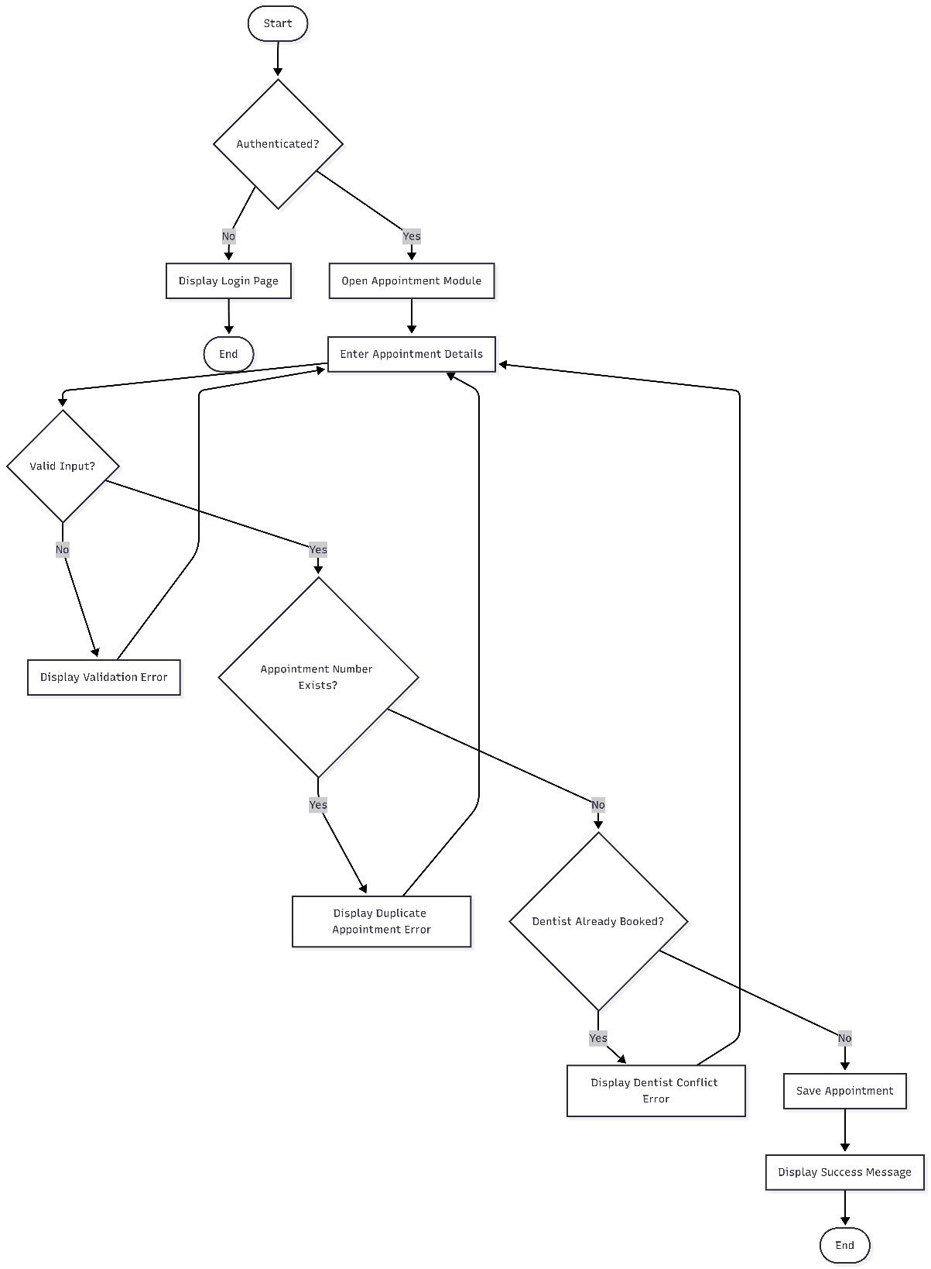
This directly addresses the double-booking problem identified in the original scenario.
Figure 8: Appointment Activity Diagram
5.15 Billing and Receipt Generation
The billing module calculates charges using treatment information.
The calculation is:
Total = Consultation Fee + Treatment Cost
For example:
Charge | Amount
Consultation Fee | Rs. 2,000.00
Treatment Cost | Rs. 8,000.00
Total | Rs. 10,000.00
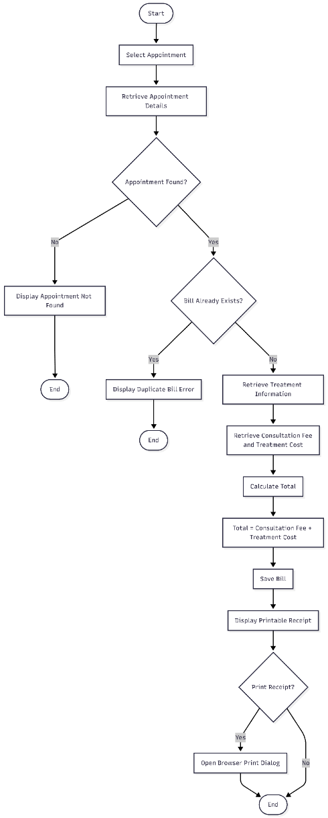
The system prevents duplicate billing for an appointment.
A printable receipt is generated through the browser's print functionality.
The receipt contains patient, appointment, treatment and financial information.

Figure 9: Billing Activity Diagram
5.16 Reporting
The system provides operational and financial reports.
Financial information includes:
- Gross revenue
- Consultation revenue
- Treatment revenue
- Number of invoices
- Average bill value
Additional reports include:
- Treatment performance
- Dentist performance
- Patient visit history
- Appointment status distribution
These reports provide information that would be difficult to produce efficiently using paper records.
5.17 Help and User Guidance
A dedicated Help module was implemented to assist new staff.
It provides step-by-step guidance covering:
- Logging in
- Navigating the dashboard
- Registering patients
- Scheduling appointments
- Searching appointments
- Generating bills
- Printing receipts
- Viewing reports
- Logging Out
This reduces the learning curve for new employees.

6. Database Design
6.1 Database Structure
The relational database contains six main entities.
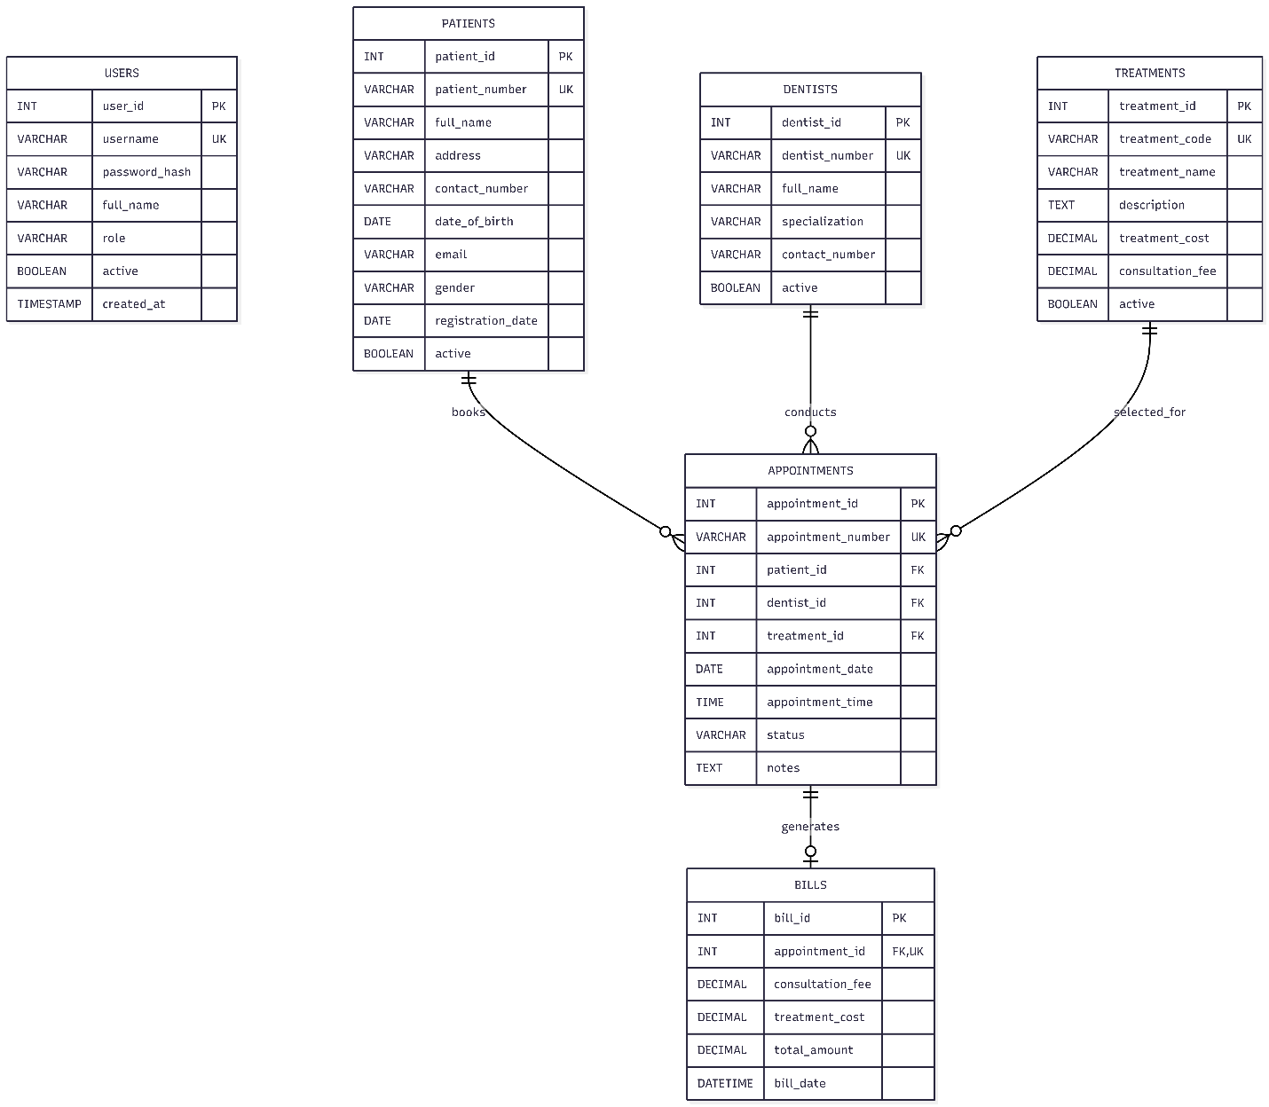
Figure 10: ER Diagram
Users
Stores staff authentication and authorization information.
Patients
Stores patient demographic and contact information.
Dentists
Stores dentist information.
Treatments
Stores treatment descriptions and prices.
Appointments
Connect patients, dentists and treatments.
Bills
Stores financial information associated with appointments.

6.2 Relationships
The main relationships are:
Patient 1 ─────── * Appointment

Dentist 1 ─────── * Appointment

Treatment 1 ───── * Appointment

Appointment 1 ─── 0..1 Bill
This structure reflects the real-world relationships within a dental clinic.
A patient can attend multiple appointments.
A dentist can conduct multiple appointments.
Treatment can be used in multiple appointments.
An appointment can have zero or one bill.

6.3 Data Integrity
Database constraints are used to maintain data consistency.
Examples include:
- Primary keys
- Unique constraints
- Foreign keys
- NOT NULL constraints
- Boolean status fields
- Decimal fields for financial values
The appointment_id field in the bills table is unique, ensuring that an appointment cannot have multiple bills.
Foreign key restrictions also prevent records from being removed when dependent historical information exists.

6.4 Normalization
The database separates different concepts into different tables.
For example, treatment prices are not repeatedly stored inside appointment records. Instead, an appointment references the treatment using treatment_id.
Similarly, patient details are stored once on the patient table rather than being duplicated across every appointment.
This reduces unnecessary duplication and improves consistency.

7. Validation, Security and Error Handling
Validation is implemented at multiple levels.
Client-Side Validation
HTML validation is used for:
- Required fields
- Email formats
- Date input
- Time input
- Maximum lengths
- Telephone input
Client-side validation improves usability by identifying simple errors immediately.
Server-Side Validation
Server-side validation is essential because browser validation can be bypassed.
The service layer checks:
- Empty fields
- Invalid IDs
- Duplicate identifiers
- Invalid roles
- Invalid appointment statuses
- Negative fees
- Invalid dates
- Duplicate bills
- Appointment conflicts
Database Validation
The database provides another protection layer through:
- Unique constraints
- Foreign keys
- NOT NULL constraints
- Data types

Security
The system uses:
- BCrypt password hashing
- Session authentication
- Role-based authorization
- Prepared statements
- Input validation
- Account status checking
No password should be stored as plaintext.

8. User Interface and User Experience
The system uses a consistent interface throughout the application.
The dashboard provides quick access to major modules.
Information is presented through tables, cards, forms and status indicators.
Success messages confirm completed operations, while error messages explain why an operation failed.
For example, rather than displaying a technical database exception, the system can provide a user-friendly message such as:
"This dentist already has an appointment at the selected date and time."
This is important because normal clinic staff should not need technical knowledge to understand system errors.
The billing interface also includes a dedicated printable receipt layout.

9. Testing and Test-Driven Development
9.1 Testing Strategy
Testing was performed to identify defects and verify that the system satisfies functional requirements.
The main testing levels considered were:
- Unit testing
- Integration-oriented testing
- Validation testing
- Database testing
- User interface testing
- Security-related testing
JUnit was selected for automated Java testing, while Mockito can be used to isolate dependencies during unit tests.

9.2 TDD Approach
Test-driven development involves creating tests around expected behaviour and then implementing functionality to satisfy those tests.
For important business rules, expected outcomes were identified before or alongside implementation.
For example, appointment conflict detection should satisfy the following rule:
If a dentist already has a non-cancelled appointment at the same date and time, another appointment should not be accepted.
Similarly, billing should satisfy:
The total amount must equal the consultation fee plus the treatment cost.
Testing these rules provides greater confidence than relying only on manually testing the interface.

9.3 Test Data
Example test data included:
Valid User
Username: receptionist01
Password: Reception123
Role: RECEPTIONIST
Valid Patient
Patient Number: PAT-001
Name: Test Patient
Contact: 0712345678
Valid Appointment
Appointment Number: APP-001
Patient: PAT-001
Dentist: DEN-001
Treatment: TRT-001
Date: 2026-08-28
Time: 10:00
Invalid Appointment
An appointment using the same dentist, date and time as an existing active appointment was used to verify conflict prevention.

9.4 Automated Testing
The implemented test suite contains 12 test classes and 87 automated tests.
Test Area | Tests
User Servlet | 11
Dentist DAO | 5
Patient DAO | 3
User DAO | 2
Appointment Service | 9
Authentication Service | 6
Billing Service | 8
Dentist Service | 7
Patient Service | 5
Treatment Service | 7
User Service | 23
Database Connection | 1
Total | 87

9.5 Test Cases
TC_USR_001 — Last Administrator Deactivation
TEST CASE RUN LOG: TC_USR_001
Test Scenario | Safeguard Against Last Administrator Deactivation
Test Objective | Ensure system prevents deactivating the sole remaining active Administrator account.
Preconditions | Exactly one active Administrator account exists in the system.
Test Data | userId: ADMIN-001, is_active: false
Test Steps | 1. Log in as Administrator.  2. Open User Management.  3. Attempt to deactivate the sole active Administrator.
Expected Result | System rejects the action to prevent system lockout.
Actual Result | Deactivation blocked and appropriate error message displayed.
Status | PASS
Visual Evidence | [FIGURE PLACEHOLDER 21: Last Administrator Safeguard Alert]

TC_USR_002 — Valid User Login
TEST CASE RUN LOG: TC_USR_002
Test Scenario | Valid User Authentication
Test Objective | Verify that a registered active user can log into the system.
Preconditions | Active user account exists.
Test Data | Username: receptionist01  Password: Reception123
Test Steps | - Open login page.  - Enter valid username and password  - Click Login.
Expected Result | User is authenticated and redirected to the dashboard.
Actual Result | Login successful and dashboard displayed.
Status | PASS
Visual Evidence | [FIGURE PLACEHOLDER 22: Successful Login/Dashboard]

TC_USR_003 — Invalid Password
TEST CASE RUN LOG: TC_USR_003
Test Scenario | Invalid Password Authentication
Test Objective | Ensure login is rejected when an incorrect password is supplied.
Preconditions | Registered active user exists.
Test Data | Username: receptionist01  Password: WrongPassword123
Test Steps | - Open login page.  - Enter valid username and incorrect password  - Click Login.
Expected Result | System rejects authentication and displays an error message
Actual Result | Login rejected and error displayed.
Status | PASS
Visual Evidence | [FIGURE PLACEHOLDER 23: Invalid Login Message]

TC_USR_004 — Disabled User Login
TEST CASE RUN LOG: TC_USR_004
Test Scenario | Disabled User Authentication
Test Objective | Ensure inactive accounts cannot access the system.
Preconditions | User account exists and is inactive.
Test Data | Disabled user: receptionist02
Test Steps | - Open login page.  - Enter disabled user's credentials.  - Click Login.
Expected Result | System rejects login because the account is inactive.
Actual Result | Login rejected and appropriate message displayed.
Status | PASS
Visual Evidence | [FIGURE PLACEHOLDER 24: Disabled Account Message]

TC_USR_005 — Duplicate Username
TEST CASE RUN LOG: TC_USR_005
Test Scenario | Duplicate Username Registration
Test Objective | Ensure two users cannot be registered with the same username.
Preconditions | Username receptionist01 already exists.
Test Data | Username: receptionist01
Test Steps | 1. Open User Management.  2. Select Add User.  3. Enter an existing username.  4. Submit the form.
Expected Result | Registration is rejected due to duplicate username.
Actual Result | Duplicate username rejected.
Status | PASS
Visual Evidence | [FIGURE PLACEHOLDER 25: Duplicate Username Alert]

Patient Management
TC_PAT_001 — Register Valid Patient
TEST CASE RUN LOG: TC_PAT_001
Test Scenario | Register New Patient
Test Objective | Verify that valid patient information can be saved.
Preconditions | User is authenticated and authorized.
Test Data | Patient No: PAT-001  Name: Test Patient  Contact: 0712345678
Test Steps | 1. Open Patient Management.  2. Enter valid patient information.  3. Submit the form.
Expected Result | Patient record is created successfully.
Actual Result | Patient successfully registered.
Status | PASS
Visual Evidence | [FIGURE PLACEHOLDER 26: Patient Registration Success]

TC_PAT_002 — Duplicate Patient Number
TEST CASE RUN LOG: TC_PAT_002
Test Scenario | Duplicate Patient Number
Test Objective | Ensure patient numbers are unique.
Preconditions | PAT-001 already exists.
Test Data | Patient No: PAT-001
Test Steps | 1. Open Patient Registration.  2. Enter an existing patient number.  3. Submit the form.
Expected Result | System rejects the duplicate patient number.
Actual Result | Duplicate patient number rejected.
Status | PASS
Visual Evidence | [FIGURE PLACEHOLDER 27: Duplicate Patient Number]

TC_PAT_003 — Patient Search
TEST CASE RUN LOG: TC_PAT_003
Test Scenario | Search Patient by Patient Number
Test Objective | Verify staff can retrieve an existing patient quickly.
Preconditions | PAT-001 exists in database.
Test Data | Patient No: PAT-001
Test Steps | 1. Open Patient Search.  2. Enter PAT-001.  3. Execute search.
Expected Result | Matching patient information is displayed.
Actual Result | Correct patient record displayed.
Status | PASS
Visual Evidence | [FIGURE PLACEHOLDER 28: Patient Search Result]

TC_PAT_004 — Required Patient Fields
TEST CASE RUN LOG: TC_PAT_004
Test Scenario | Patient Form Validation
Test Objective | Ensure required patient fields cannot be submitted empty.
Preconditions | Patient registration page is open.
Test Data | Full Name: empty
Test Steps | 1. Leave required fields empty.  2. Submit the form.
Expected Result | System rejects submission and identifies missing information.
Actual Result | Validation message displayed and record not created.
Status | PASS
Visual Evidence | [FIGURE PLACEHOLDER 29: Patient Validation Message]

Dentist Management
TC_DEN_001 — Register Dentist
TEST CASE RUN LOG: TC_DEN_001
Test Scenario | Register New Dentist
Test Objective | Verify valid dentist information can be stored.
Preconditions | Authorized user is logged in.
Test Data | Dentist No: DEN-001  Name: Dr. Test Dentist  Specialization: General Dentistry
Test Steps | 1. Open Dentist Management.  2. Enter valid dentist’s information.  3. Save record.
Expected Result | Dentist record is created successfully.
Actual Result | Dentist successfully registered.
Status | PASS
Visual Evidence | [FIGURE PLACEHOLDER 30: Dentist Registration]

TC_DEN_002 — Dentist Deactivation
TEST CASE RUN LOG: TC_DEN_002
Test Scenario | Dentist Soft Deactivation
Test Objective | Verify dentist can be deactivated without deleting historical data
Preconditions | Active dentist exists.
Test Data | Dentist No: DEN-001
Test Steps | 1. Open Dentist Management.  2. Select active dentist.  3. Deactivate dentist.
Expected Result | Dentists become inactive while historical records remain.
Actual Result | Dentist successfully deactivated.
Status | PASS
Visual Evidence | [FIGURE PLACEHOLDER 31: Dentist Deactivation]

Treatment Management
TC_TRT_001 — Register Treatment
TEST CASE RUN LOG: TC_TRT_001
Test Scenario | Register New Treatment
Test Objective | Verify treatment details and fees can be stored.
Preconditions | Authorized user is logged in.
Test Data | Code: TRT-001  Name: Dental Filling  Cost: Rs. 8000.00  Consultation Fee: Rs. 2000.00
Test Steps | 1. Open Treatment Management.  2. Enter valid treatment information.  3. Save treatment.
Expected Result | Treatment is successfully created.
Actual Result | Treatment successfully created.
Status | PASS
Visual Evidence | [FIGURE PLACEHOLDER 32: Treatment Registration]

TC_TRT_002 — Negative Treatment Fee
TEST CASE RUN LOG: TC_TRT_002
Test Scenario | Invalid Treatment Fee
Test Objective | Ensure negative treatment costs are rejected.
Preconditions | Treatment form is open.
Test Data | Treatment Cost: -5000.00
Test Steps | 1. Enter treatment information.  2. Enter a negative treatment cost.  3. Submit form.
Expected Result | System rejects the invalid fee.
Actual Result | Negative fee rejected with validation message.
Status | PASS
Visual Evidence | [FIGURE PLACEHOLDER 33: Invalid Treatment Fee]

Appointment Management
TC_APP_001 — Register Valid Appointment
TEST CASE RUN LOG: TC_APP_001
Test Scenario | Register New Appointment
Test Objective | Verify valid appointment information can be stored.
Preconditions | Valid patient, dentist and treatment exist.
Test Data | Appointment: APP-001  Patient: PAT-001  Dentist: DEN-001  Treatment: TRT-001  Date: 2026-08-28  Time: 10:00
Test Steps | 1. Open Appointment Management.  2. Select patient, dentist and treatment.  3. Enter date and time.  4. Submit appointment.
Expected Result | Appointment is successfully created.
Actual Result | Appointment successfully created.
Status | PASS
Visual Evidence | Appointment successfully created.

TC_APP_002 — Duplicate Appointment Number
TEST CASE RUN LOG: TC_APP_002
Test Scenario | Duplicate Appointment Number
Test Objective | Ensure appointment numbers remain unique.
Preconditions | APP-001 already exists.
Test Data | Appointment Number: APP-001
Test Steps | 1. Create a new appointment.  2. Enter existing appointment number.  3. Submit.
Expected Result | Appointment is rejected.
Actual Result | Duplicate appointment number rejected.
Status | PASS
Visual Evidence | [FIGURE PLACEHOLDER 35: Duplicate Appointment Alert]

TC_APP_003 — Dentist Schedule Conflict
TEST CASE RUN LOG: TC_APP_003
Test Scenario | Dentist Double-Booking Prevention
Test Objective | Ensure a dentist cannot have two active appointments at the same date and time.
Preconditions | Existing active appointment for DEN-001 at 10:00 exists.
Test Data | Dentist: DEN-001  Date: 2026-08-28  Time: 10:00
Test Steps | 1. Create another appointment.  2. Select DEN-001.  3. Enter the same date and time.  4. Submit appointment.
Expected Result | System rejects appointment because dentist is already booked.
Actual Result | Appointment rejected and conflict message displayed.
Status | PASS
Visual Evidence | [FIGURE PLACEHOLDER 36: Dentist Conflict Alert]

TC_APP_004 — Cancelled Appointment Conflict
TEST CASE RUN LOG: TC_APP_004
Test Scenario | Appointment Allowed After Cancellation
Test Objective | Verify a cancelled appointment does not block a new appointment.
Preconditions | Existing appointment at selected time has CANCELLED status.
Test Data | Dentist: DEN-001  Date: 2026-08-28  Time: 10:00
Test Steps | 1. Create appointment at same date and time.  2. Submit appointment.
Expected Result | New appointment is accepted because previous appointment is cancelled..
Actual Result | New appointment successfully created.
Status | PASS
Visual Evidence | [FIGURE PLACEHOLDER 37: Appointment Success]

TC_APP_005 — Invalid Appointment Status
TEST CASE RUN LOG: TC_APP_005
Test Scenario | Appointment Status Validation
Test Objective | Ensure unsupported appointment statuses are rejected.
Preconditions | Appointment exists.
Test Data | Status: INVALID_STATUS
Test Steps | 1. Attempt to save appointment with invalid status.  2. Submit update.
Expected Result | System rejects invalid appointment status.
Actual Result | Invalid status rejected.
Status | PASS
Visual Evidence | [FIGURE PLACEHOLDER 38: Invalid Status Message]

TC_APP_006 — Appointment Search
TEST CASE RUN LOG: TC_APP_006
Test Scenario | Search Appointment by Appointment Number
Test Objective | Verify staff can retrieve an appointment using its unique number.
Preconditions | APP-001 exists.
Test Data | Appointment Number: APP-001
Test Steps | 1. Open Appointment Search.  2. Enter APP-001.  3. Execute search.
Expected Result | Correct appointment details are displayed.
Actual Result | Appointment information displayed correctly.
Status | PASS
Visual Evidence | [FIGURE PLACEHOLDER 39: Appointment Search Result]

Billing
TC_BIL_001 — Correct Bill Calculation
TEST CASE RUN LOG: TC_BIL_001
Test Scenario | Automatic Bill Calculation
Test Objective | Verify total bill amount is calculated correctly.
Preconditions | Valid appointment and treatment exist.
Test Data | Consultation Fee: Rs. 2,000.00  Treatment Cost: Rs. 8,000.00
Test Steps | 1. Select appointment.  2. Generate bill.
Expected Result | Total = Rs. 10,000.00.
Actual Result | System calculated total as Rs. 10,000.00.
Status | PASS
Visual Evidence | [FIGURE PLACEHOLDER 40: Generated Bill]

TC_BIL_002 — Duplicate Bill Prevention
TEST CASE RUN LOG: TC_BIL_002
Test Scenario | Duplicate Bill Prevention
Test Objective | Ensure one appointment cannot have multiple bills.
Preconditions | Appointment already has a bill.
Test Data | Appointment ID: APP-001
Test Steps | 1. Select an appointment that already has a bill.  2. Attempt to generate another bill.
Expected Result | System rejects duplicate billing.
Actual Result | Duplicate bill generation blocked.
Status | PASS
Visual Evidence | [FIGURE PLACEHOLDER 41: Duplicate Bill Alert]

TC_BIL_003 — Receipt Printing
TEST CASE RUN LOG: TC_BIL_003
Test Scenario | Printable Receipt Generation
Test Objective | Verify generated bills can be printed as receipts.
Preconditions | Valid bill exists.
Test Data | Bill associated with APP-001
Test Steps | 1. Open generated bill.  2. Select Print Receipt.
Expected Result | Browser print interface opens with correctly formatted receipt.
Actual Result | Printable receipt displayed successfully.
Status | PASS
Visual Evidence | [FIGURE PLACEHOLDER 42: Printable Receipt]

Security / Authorization
TC_SEC_001 — Unauthorized User Management Access
TEST CASE RUN LOG: TC_SEC_001
Test Scenario | Role-Based Access Control
Test Objective | Ensure non-administrator users cannot access User Management.
Preconditions | User is logged in as Receptionist.
Test Data | Role: RECEPTIONIST
Test Steps | 1. Log in as receptionist.  2. Attempt to access User Management.
Expected Result | Access is denied or module is unavailable.
Actual Result | Receptionist access was blocked.
Status | PASS
Visual Evidence | [FIGURE PLACEHOLDER 43: Access Denied]

TC_SEC_002 — Unauthenticated Protected Page
TEST CASE RUN LOG: TC_SEC_002
Test Scenario | Authentication Filter Protection
Test Objective | Ensure protected pages cannot be accessed without login.
Preconditions | User is logged out.
Test Data | Protected URL: /appointments
Test Steps | 1. Log out of the application.  2. Attempt to directly access a protected page.
Expected Result | User is redirected to the login page.
Actual Result | Protected page access was blocked and login page displayed.
Status | PASS
Visual Evidence | [FIGURE PLACEHOLDER 44: Authentication Redirect]

Reporting
TC_RPT_001 — Financial Report
TEST CASE RUN LOG: TC_RPT_001
Test Scenario | Generate Financial Report
Test Objective | Verify the system correctly summarizes financial information.
Preconditions | Completed bills exist in the database.
Test Data | Existing bill records
Test Steps | 1. Open Reports.  2. Select Financial Report.  3. Generate report.
Expected Result | Revenue, invoice count and average bill values are displayed.
Actual Result | Financial report generated successfully.
Status | PASS
Visual Evidence | [FIGURE PLACEHOLDER 45: Financial Report]

TC_RPT_002 — Appointment Status Report
TEST CASE RUN LOG: TC_RPT_002
Test Scenario | Appointment Status Report
Test Objective | Verify appointments are correctly grouped by status.
Preconditions | Appointments with different statuses exist.
Test Data | SCHEDULED, COMPLETED, CANCELLED, NO_SHOW
Test Steps | 1. Open Reports.  2. Select Appointment Status Report.  3. Generate report.
Expected Result | Correct appointment status distribution is displayed.
Actual Result | Status report generated correctly.
Status | PASS
Visual Evidence | [FIGURE PLACEHOLDER 46: Appointment Status Report]

These tests focus particularly on business rules where errors could affect security, scheduling or financial accuracy.

10. Task D – Git, GitHub and Version Control
Git was selected as the version-control system for managing source-code development.
The repository should contain:
sunrise-dental/
├── database/
├── src/
├── pom.xml
├── README.md
└── .gitignore
Git provides a historical record of development changes.
A suitable workflow is:
Working Directory
|
v
git add
|
v
Staging Area
|
v
git commit
|
v
Local Repository
|
v
git push
|
v
GitHub Repository
Meaningful commits should be used instead of a single final commit.
Example development history:
Initial project structure
Added database schema
Implemented authentication
Added patient management
Added dentist management
Added treatment management
Implemented appointment scheduling
Added appointment conflict validation
Implemented billing
Added reporting
Added automated tests
Improved UI and validation
Final deployment preparation
Each commit provides evidence of incremental development.
For the final report, the actual public GitHub repository link should be inserted here:
GitHub Repository: [INSERT YOUR GITHUB URL]
The GitHub repository should also demonstrate multiple versions and regular updates as required by Task D.

11. System Evaluation
The completed system addresses the primary problems identified in the scenario.
Original Problem | Implemented Solution
Paper-based records | Centralized MySQL database
Double bookings | Dentist conflict checking
Lost patient information | Electronic patient records
Slow searching | Patient and appointment lookup
Billing errors | Automated calculation
Unauthorized access | Authentication and RBAC
Difficult reporting | Automated reports
New staff difficulty | Help section

The layered architecture also provides technical benefits.
A change to database implementation can generally be isolated within the DAO layer.
Business rules can be modified within service classes without redesigning the entire interface.
Similarly, JSP pages can be updated without moving SQL code into the presentation layer.

12. Limitations and Future Enhancements
Although the system satisfies the major requirements, several limitations remain.
Online Payments
The current billing module generates invoices and printable receipts but does not integrate an online payment gateway.
Notifications
The system does not currently send automated SMS or email appointment reminders.
Treatment Duration
Appointment conflict detection currently considers the exact appointment date and start time rather than variable treatment durations.
A future version could introduce treatment duration and calculate overlapping time intervals.

Advanced Patient Medical History
The current system focuses primarily on demographic, appointment and billing information.
A future version could introduce detailed clinical records, allergies, medical history, prescriptions and treatment notes.
Multi-Branch Support
The current design assumes a single Sunrise Dental location.
A future version could introduce branch management.
Advanced Reporting
Future reports could include:
- Monthly revenue charts
- Dentist utilization
- Most common treatments
- Patient retention
- Appointment cancellation trends

13. Conclusion
The Sunrise Dental Management System provides a computerized solution to the operational problems associated with the manual management process described in the scenario.
The system implements secure authentication, role-based authorization, patient registration, dentist management, treatment management, appointment scheduling, conflict prevention, billing, receipt printing, reporting and user assistance.
The use of Java 23, Jakarta Servlets, JSP, JDBC, MySQL, Maven and Apache Tomcat provides an appropriate technology foundation for the assignment while maintaining a framework-independent architecture.
The layered architecture separates presentation, request handling, business logic, data access and persistent storage. This improves maintainability and allows individual components to be tested independently.
The database design uses primary keys, foreign keys, unique constraints and other integrity mechanisms to protect data consistency. Application-level validation further ensures that incorrect information is not accepted.
Security was addressed through BCrypt password hashing, session-based authentication, role-based authorization and parameterized SQL queries.
Automated testing was incorporated using JUnit and Mockito, with the implemented test suite reporting 87 successful tests and no failures or errors.
Git and GitHub provide version control and evidence of incremental software development.
Overall, the system provides a practical foundation for Sunrise Dental Clinic to move from manual paper-based administration toward a centralized computerized management environment. Future development could extend the system with online payments, automated notifications, detailed clinical histories, treatment-duration scheduling and multi-branch support.

14. References
For the final submission, references should be maintained in Harvard format. Suitable authoritative sources include the official documentation for the technologies used, together with appropriate software engineering literature.
Examples:
Apache Software Foundation (n.d.) Apache Tomcat documentation. Available at: official Apache Tomcat documentation (Accessed: 28 August 2026).
Eclipse Foundation (n.d.) Jakarta Servlet specification. Available at: official Jakarta EE documentation (Accessed: 28 August 2026).
JUnit Team (n.d.) JUnit 5 User Guide. Available at: official JUnit documentation (Accessed: 28 August 2026).
MySQL (n.d.) MySQL 8.0 Reference Manual. Available at: official MySQL documentation (Accessed: 28 August 2026).
Oracle (n.d.) Java documentation. Available at: official Java documentation (Accessed: 28 August 2026).
OWASP Foundation (n.d.) OWASP SQL Injection Prevention Cheat Sheet. Available at: official OWASP documentation (Accessed: 28 August 2026).

15. Appendices
Appendix A – Use Case Diagram
Insert final UML Use Case Diagram.
Appendix B – Class Diagram
Insert final UML Class Diagram.
Appendix C – Sequence Diagrams
Insert login sequence diagram.
Insert appointment registration sequence diagram.
Insert billing sequence diagram.
Appendix D – Database ER Diagram
Insert database ER diagram.
Appendix E – Application Screenshots
Recommended screenshots:
- Login page
- Dashboard
- Patient registration
- Patient search
- Dentist management
- Treatment catalogue
- Appointment registration
- Appointment search
- Billing page
- Printable receipt
- Reports
- User management
- Help section
Appendix F – Testing Evidence
Include screenshots of:
mvn clean test
showing:
Tests run: 87
Failures: 0
Errors: 0
Skipped: 0
BUILD SUCCESS
Appendix G – GitHub Evidence
Include screenshots showing:
- Repository
- Commit history
- Multiple versions
- Branches, if used
- Pull requests, if used
- GitHub project structure

